R34 Interoception Analysis Project



Float Clinic Research Center (FCRC)

November, 2019

REV: H

Contents

Contact Information 4

Terms and Definitions 5

Experiment Description 7

Project Requirements 8

Program Requirements 8

Budget 8

Skills Required 8

Project Overview 9

Program Data Organization 12

Program Layout 13

Main Pseudocode 13

Classic Algorithm 14

T-1000 Algorithm 15

File Structure 16

File Naming 16

File Structure 16

Raw Data Files 17

Metrics 18

Graphs 18

GUI Function 19

GUI Strategy 19

GUI Format 20

(Not) Reinventing the GUI Wheel 20

ECG Data on Display 20

ECG Automatic Detections 20

ECG Detection Interaction 22

Save Function and Feedback 23

Milestones 24

Code Review and Acceptance Test Procedure 24

Code Review 24

Acceptance Test Procedures (ATP) 24

Revision History 25

# Contact Information

**Justin Feinstein.**

Clinical Neuropsychologist  
Director, LIBR Float Clinic & Research Center  
  
Principal Investigator  
Laureate Institute for Brain Research  
  
Email: [jfeinstein@laureateinstitute.org](mailto:jfeinstein@laureateinstitute.org)**|** Phone: 918-502-5169

**Will Schoenhals**

Masters of Engineering Research Assistant, graduated 2018

Electrical Engineering Contractor

Email: [williamashoe@gmail.com](mailto:williamashoe@gmail.com) | Phone: 918-813-3156

# Terms and Definitions

**Laureate Institute of Brain Research (LIBR).** Part of St. Francis hospital in Tulsa, OK. Supports research into mental health and treatments.

**Float Clinic and Research Center (FCRC).** Laboratory started in 2015 by Justin Feinstein to study the effects of Flotation-REST.

**Relaxed Environmental Stimulation Therapy (REST).** A novel intervention that attenuates exteroceptvie sensory input to the nervous system through the act of floating supine in a pool of water saturated with nearly a ton of magnesium sulfate (Epsom salt).

**Float Tank**. A shallow pool about eight feet in diameter, filled with a solution of warm water and high concentration of Epsom salt, magnesium sulfate. The tank is situated in an environmentally controlled, light proof, sound proof room.

**Electrocardiogram (ECG).** Record of the electrical activity of the heart. Measured by reading voltage on electrodes attached to the skin.

**Control Room**. Data sink for BioPatch and Squeeze Ball data streams. Controls the floating environment and has sound and voice control to facilitate experiments.

**BioPatch**. A small, wireless device that records the ECG of a subject. Connects to the chest with two electrodes.

**Squeeze Ball.** Created by graduated Masters of Engineering student, Will Schoenhals, specifically to survive the floating environment and transmit subject response through squeezes.

**Cardiac Interoceptive Accuracy**. Still an evolving term, this measurement is a biometric that could correlate mental health with perception of the heartbeat. Accuracy describes the ability to recognize a heartbeat and self-report it by squeezing. The result is binary. The heartbeat was recognized with a squeeze or it was not.

**Cardiac Interoceptive Precision.** Similar to Cardiac Interoceptive Accuracy. Precision describes the time delay between a heartbeat occurring and the resulting squeeze. The result is time delay in milliseconds.

**Real Time Clock (RTC).** Integrated circuit on wireless devices to keep track of time. Requires a host to initially set the time on the RTC. Due to variables delays in host and device processing the RTC will suffer some amount of time offset- enough to impact Interoceptive analysis.

**Experiment conditions.** There are three conditions: Zero Gravity Chair, Dry Float, and Closed Tank. These are separate rooms where the experiment takes place. Experiment protocol is identical between all three conditions.

**Experimental task**. Specific set of instructions the subject follows to the best of their ability. A tone rings to indicate the start/stop of the task. During the task, the subject squeezes the Squeeze Ball in response to stimuli- either their own heart beat or series of tones.

**Resampled Precision.** Method of comparing a subject’s interoceptive precision results to results generated from using their heartbeats and redistributing their detections with a normal distribution. See attached document for more information on resampled precision.

**T-1000.** Short for Tulsa 1000. Ongoing longitudinal study at LIBR where subjects come in five times over the course of a year for a series of physiological and psychiatric assessments.

**Zero Gravity Chair-** Very comfortable chair that reclines into a completely horizontal position. Used for baseline experiments in R34.

**Dry Bed.** A modified water bed. An internal platform lowers the subject into a plastic bed that is full of warm water. The subject remains dry while also being completely supported by water. Subjects are randomized to either the dry bed or the closed tank for their fourth float.

**Closed Tank.** A float tank with walls and a high ceiling. Enclosing the tank increased the humidity and control over temperature. Subjects are randomized to either the dry bed or the closed tank or dry bed for their fourth float.

# Experiment Description

One question the R34 study is investigating is the effect of floating in the Zero Gravity, Dry Bed, and Closed Tank conditions has on interoception accuracy and precision. Subjects begin the study with five interoceptive tasks in the Zero Gravity condition to establish their baseline performance before any floats. The five tasks are administered by timed, pre-recorded instructions that last about two each. In total, the tasks take ten to fifteen minutes to complete. Subjects are then randomly assigned to be a Closed Pool or a Dry Bed float schedule. They complete three separate floats, in their pre-chosen condition, for 90 minutes without interruptions. During the fourth float, the interoceptive tasks are repeated. Subjects complete two more uninterrupted floats before repeating the interoception tasks a final time in the Zero Gravity condition.

Interoception Analysis is not the only aspect of the floats under investigation. However, it is all this project will focus on. Below is the timeline of the full experiment. Only the Pre, Post and fourth float collect interoceptive data. Below is a graphic representing all the assessments completed by the subject. We are only concerned with the Squeeze Intero row.

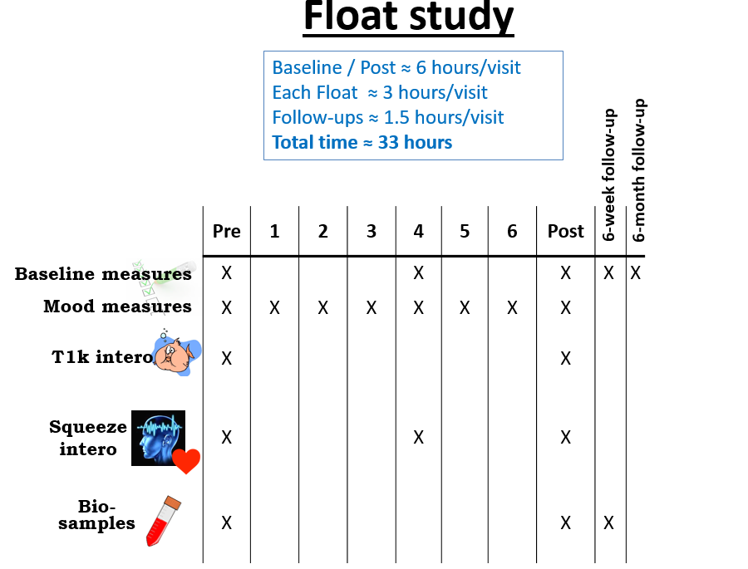

Each experiment has similar same protocol. The subject arrives at LIBR and is connected to the BioPatch and handed the Squeeze Ball. They relax in the Zero G or Closed Pool conditions and await instructions. Pre-recorded instructions are timed and played at intervals to guide the subject through a series of **five** interoception tasks. Each task lasts just over one minute. Only the squeezing and ECG data during the tasks will be used.

# Project Requirements

The R34 Intero Analysis project is the last piece of a puzzle that has been slowly built over the past four years. The inputs and outputs are understood and will serve as hard parameters to guide the project. Emphasis is placed on ease of use as the main operators will be lab members and not have any engineering or computer science training. Clear operating instructions and troubleshooting guides are required.

The pseudocode is included to guide the development of the project. However, it need not be followed exactly. Changes are expected but must be agreed upon. This document will be maintained by Will to keep control of the program configuration.

## Program Requirement Sections

|  |  |
| --- | --- |
| Requirement | Description |
| 1.0 | Code General Requirements |
| 2.0 | GUI Window Requirements |
| 3.0 | Load and Save Data Requirements |
| 4.0 | R Peak Detection and Squeeze Detection Requirements |
| 5.0 | Classic and T1000 Algorithm Requirements |
| 6.0 | Documents for installation, operation, troubleshooting are provided |
| 7.0 | Graphs are saved that clearly show ECG, Squeeze, R-Peak, and Squeeze Detections and R-Peak / Squeeze Detection pairs. |

For a comprehensive list of Program Requirements, reference the document; ‘R34 Scope of Work’

## Budget

The project is expected to take 1000 to 1500 lines of code and approximately 90 hours. Compensation is based on experience.

## Skills Required

* Proficient in Python 3.7
  + PyQT5
  + Data Visualization
  + Signal Processing
* Proficient in English and creating Instruction and Troubleshooting Manuals

# Project Overview

This project involves the investigation into the objective measure of cardiac interception- or the measure of the degree to which an individual is aware of their own heartbeat. A wireless ECG device captures data that will be inspected for R-peaks, the electrical signal generated when the heart completes its most forceful contraction, as the most likely origin of heart perception. A separate wireless device, the Squeeze Ball, is held by the subject and squeezed whenever they perceive a heartbeat. By combining the ECG and subject response data we will determine how often and how quickly subjects correctly perceive their heartbeat.

One application is expected. A single GUI, able to be operated by non-engineering lab members and supported with operation manuals and troubleshooting guides.

R-Peaks are the significant event in ECG data that signifies the temporal location of a heartbeat. There are widely available R-Peak detection algorithms that will detect >95% of R-Peaks. However, we need 100% of the R-Peaks. The noise and distortion in BioPatch data makes a ‘one size fits all’ algorithm difficult. To pick out R-Peaks, the program will need to display the ECG data with possible R-Peaks. The user will then inspect the display and make changes to R-Peak locations as needed to guarantee 100% detection. Expect false positives and false negatives in R-Peak detection.

Below is an example of the QRS Complex with R peak identified. The amplitude of the R and the T peaks are extremely variable.

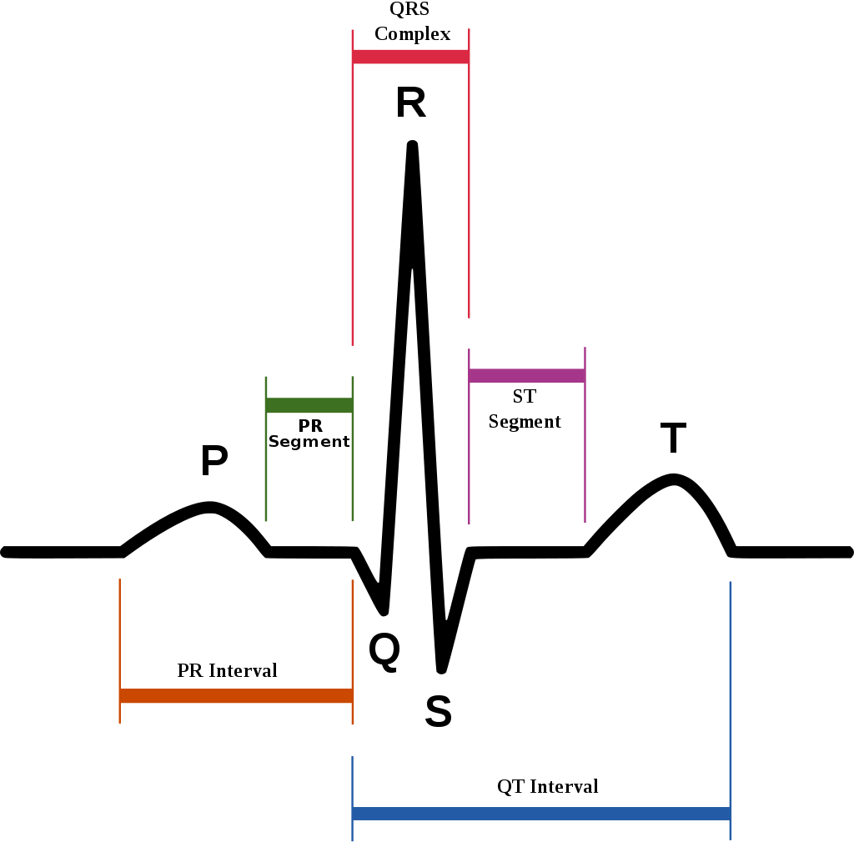

Squeezes signify when a subject has responded to their heartbeat. The squeeze waveform can last several hundred milliseconds so the peak of a squeeze occurs very far behind the first inflection of pressure. Therefore, the peak is not where a ‘detection’ occurs. The ‘detection’ is found by drawing a line between the first pressure inflection and the peak of the squeeze. The ‘detection’ occurs at exactly 20% of the distance between these two points. Below is an example of raw ECG and squeeze data for a single task.

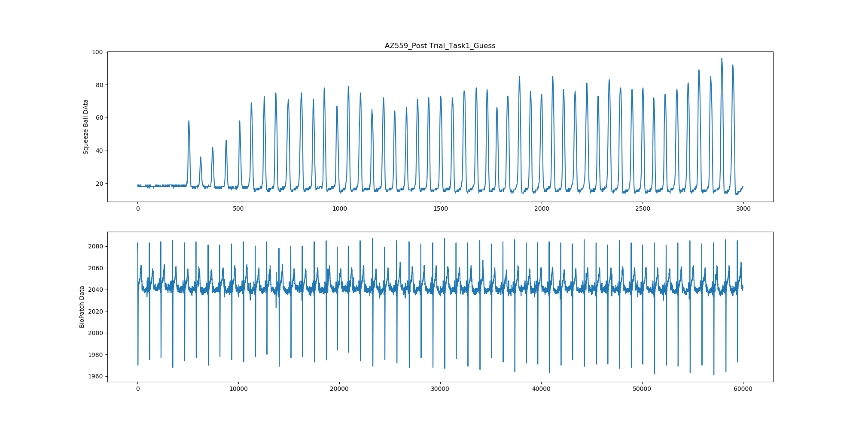

With the R-Peaks and squeeze detections known, the last step is to assign squeezes to R-peaks. Two algorithms are used to pair R-Peaks and squeezes. The ‘classic’ algorithm and the T-1000. These are explained in the Program Layout chapter.

The delay between pairs of R-Peaks and squeezes describe how many heartbeats the subject has perceived and how quickly they were able to respond.

Calculated results and graphs of the data showing R-Peak and squeeze detections and pairs are required. See Project Requirements for more info.

Below is a graph showing the combined ECG and squeeze data graphs. R-peaks and squeezes are detected and paired.

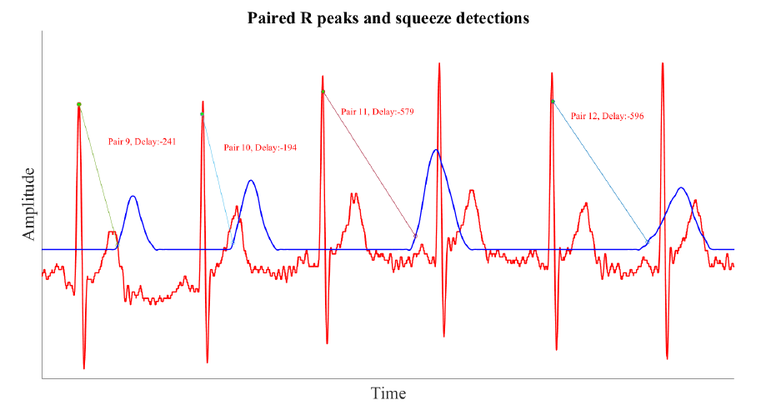

# Program Data Organization

Highlighted in **blue** are the input files that will be used for analysis and not modified.

Files in **purple** are created.

Outputs will be found under:

L:\jfeinstein\R34\Experiment Data\Outputs

Special file, Results_Amalgomate will

Within the /Outputs/ folder the data is organized as such (after a complete analysis):

* **Analysis Amalgamate**
* Subject ID (Folder)
  + Pre Condition (Folder)
    - **BioPatch Task1 Data**
    - **Squeeze Task1 Data**
    - **Task_1_Result_T1000**
    - **Task_1_Result_Classic**
    - **Task_1_Result_Image**
    - **Task_1_Result_Ouput**
    - **…**
    - **…**
    - **BioPatch Task5 Data**
    - **Squeeze Task5 Data**
    - **Task_5_Result_T1000**
    - **Task_5_Result_Classic**
    - **Task_5_Result_Image**
    - **Task_5_Result_Ouput**
  + Trial Condition (Folder)
    - Same as Pre Condition
  + Post Condition (Folder)
    - Same as Pre Condition

# Program Layout

## Main Pseudocode

>>User enters Subject ID and Trial for analysis

FOR Each of FIVE Tasks in /Outputs/Subject/Trial Folder:

LOAD BioPatch Task Data

LOAD Squeeze Task Data

IF Task 2:

Pass

# Tone times replace R-Peaks

ELSE:

Display BioPatch ECG data with possible R-Peaks

>> User inspects and changes R-Peaks

SAVE BioPatch R-Peak Detection Data

Auto-detect Squeeze detections

SAVE Squeeze Detection Data

Perform Classic Algorithm to Pair R-Peaks and Squeezes

Perform T-1000 Algorithm to Pair R-Peaks and Squeezes

Calculate Classic Algorithm Task Metrics

Calculate T-1000 Algorithm Task Metrics

Create Task Graph

SAVE Task Metrics

SAVE Task Graphs

## Classic Algorithm

1. Each squeeze detection is paired to the nearest, leading R-Peak.
2. Calculate latency between R-Peak and squeeze detection for all pairs.
3. Omit the squeeze detection(s) with the longest latency if multiple squeeze detection(s) are paired to the same R-Peak.
4. Organize the latency of all pairs into a single vector for analysis

Calculate on Classic Algorithm Vector:

MAX of Latency Values

MIN of Latency Values

STD of Latency Values

MEAN of Latency Values

Number of Heartbeats

Number of Pairs

Number of Raw Squeezes

Number of Omitted Squeezes

MAX of Intensity Values of all Squeezes

MIN of Intensity Values of all Squeezes

STD of Intensity Values of all Squeezes

MEAN of Intensity Values of all Squeezes

## T-1000 Algorithm

1. Determine Pulse Transit Time (PTT) for all R-Peaks by adding 200ms to each R-Peak
2. Create ▲PTT window between each pair of PTT points
3. Calculate the limits of a new “detection window” created between the first half of a ▲PTT window and the second half of the next ▲PTT window. The zero-point is where the two ▲PTT meet
4. For each squeeze detection(s) within a “detection window”, calculate latency between squeeze detection(s) and zero-point of the window. Squeeze detections can be positive or negative
5. Save all latencies into a single vector for analysis
6. Calculate Resampled Mean

Calculate on T-1000 Latency Vector:

MEAN of Latency Values

STD of Latency Values (used in RESAMPLED PRECISION Score)

RESAMPLED PRECISION Score

Number of Heartbeats without any Detections

Below describes the process to calculate Resampled Precision (credit to Rayus Kuplicki and Ryan Smith)

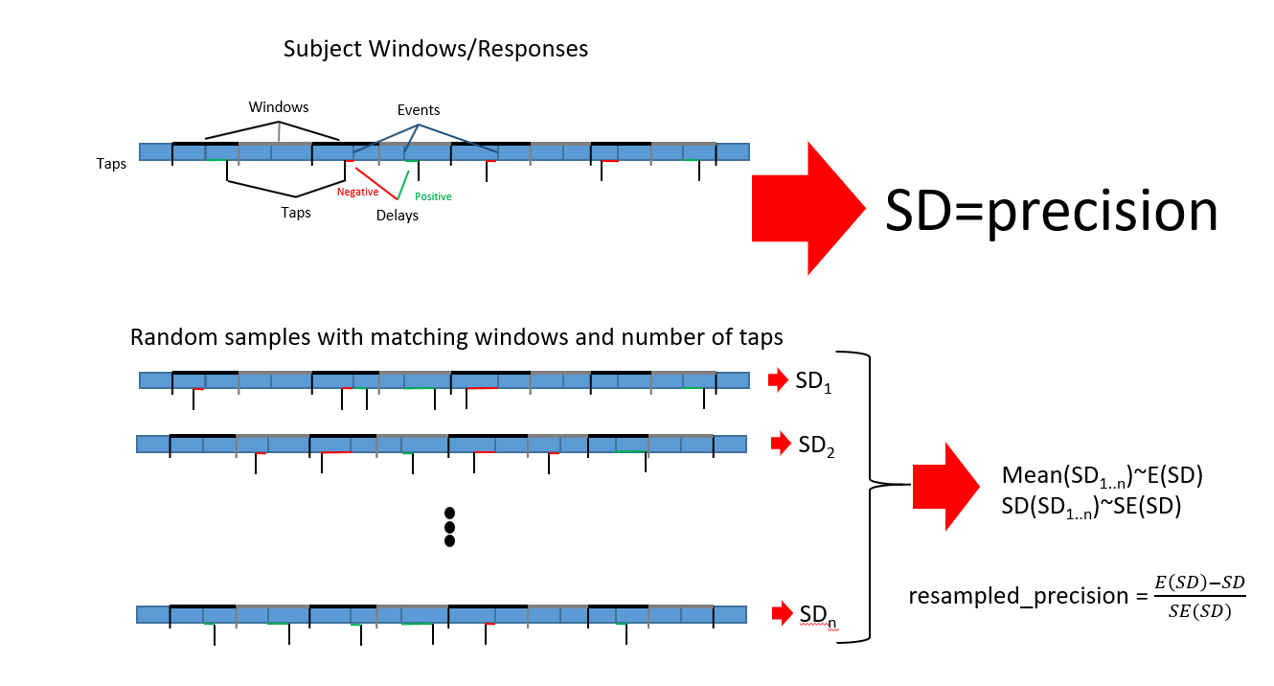

Below describes how to create ▲PTT windows and assign detections:

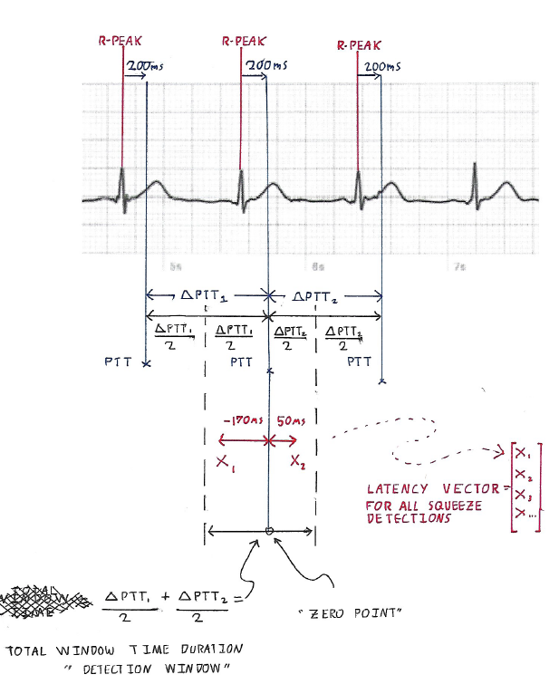

## Analysis Amalgamate

The GUI will walk through all /outputs/ and add all append all data from Classic and T-1000 files to a single .CSV. As the analysis grows, so will this file. Analysis Amalgamate is prompted by a button on the GUI and will overwrite the previous Analysis Amalgamate.

## File Structure

Eleven files will be created, or overwritten in the event of a redo. Ten will be text files- a Classic Analysis and a T1000 analysis for each of the five tasks. One file will be a large .PNG containing a visualization of all five tasks.

### File Naming

#### Classic and T1000 analysis text files be will named as:

[Subject ID]_[Condition]_[Task#]_[Analysis Type].CSV

**Subject**: Five character ID. First two characters are always capitalized alphabet. Last three characters are always 0-9.

**Condition**: Either Pre Trial, Trial, or Post Trial

**Task#:** Task1 through Task5

**Analysis Type:** Either Classic or T1000

#### Imags named as:

[Subject ID]_[Condition]_[Trial].PNG

**Subject**: Five character ID. First two characters are always capitalized alphabet. Last three characters are always 0-9.

**Condition**: Either Pre Trial, Trial, or Post Trial

#### Analysis Amalgamate will be named as:

R34_Intero_Analysis.CSV

### File Contents

Both Classic and T-1000 analysis files will have two rows. The first row contains headers for all the metrics listed above in the Classic and T-1000 Algorithm sections. The second row contains values for each metric.

For the Analysis Amalgamate, the first row will contain headers from both Classic and T-1000 files. Data is not repeated between Classic and T-1000 files. Additionally, four headers are included for Subject, Condition, Experiment Location, and Task. Each row is a single trial, so a subject who has completed R34 study will occupy fifteen rows.

Below are the metrics and type of return value for the Classic Algorithm:

|  |  |  |  |  |
| --- | --- | --- | --- | --- |
| Metric | Max Latency | MIN Latency | STD Latency | MEAN Latency |
| Return Type | Milliseconds | Milliseconds | Milliseconds | Milliseconds |

|  |  |  |  |  |
| --- | --- | --- | --- | --- |
| Metric | Num of HB | Num of Pairs | Raw Squeeze | Omitted Squeeze |
| Return Type | Int | Int | Int | Int |

|  |  |  |  |  |
| --- | --- | --- | --- | --- |
| Metric | MAX Intensity | Min Intensity | STD Latency | MEAN Latency |
| Return Type | Relative Pressure | Relative Pressure | Relative Pressure | Relative Pressure |

Below are the metrics and type of return value for the T-1000 Algorithm:

|  |  |  |  |  |
| --- | --- | --- | --- | --- |
| Metric | Mean Latency | STD Latency | Resampled Precision | Num HBs with no detections |
| Return Type | Milliseconds | Milliseconds | Float | Int |

|  |  |  |  |  |  |
| --- | --- | --- | --- | --- | --- |
| Metric | Num of HB | Num of Squeeze | Num of Pairs | Raw Squeeze | Omitted Squeeze |
| Return Type | Int | Int | Int | Int | Int |

|  |  |  |  |  |
| --- | --- | --- | --- | --- |
| Metric | MAX Intensity | Min Intensity | STD Latency | MEAN Latency |
| Return Type | Relative Pressure | Relative Pressure | Relative Pressure | Relative Pressure |

Below are the metrics and return type for Analysis Amalgamate:

|  |  |  |  |  |  |
| --- | --- | --- | --- | --- | --- |
| Sub ID | Experiment | Condition | Task Number | All Classic Metrics | All T-1000 Metrics |
| String | String | String | Int | All Classic Results | All T-1000 Results |

### Image

The image will contain five layers, organized in one place. Base layer contains ECG and Squeeze data on the same axis. ECG should be in red and Squeeze should be in blue.

1. ECG Data
2. R Peaks
3. Squeeze Data
4. Squeeze Detections
5. Line or other indication of Classic pairing of R Peaks and Squeezes

Below is an example containing all layers represented on one graph.

**Special Note:** BioPatch samples at 1000HZ and Squeeze Ball samples at 50HZ. To plot them both on the same graph, consider interpolating the Squeeze to 1000HZ. However, use interpolated data *only* for drawing the graph and not for analysis.

### Raw Data Files

The raw data file is a two column CSV file. The first column is an INT containing ECG signal for BioPatch and pressure for Squeeze Ball device. The second column is BOOLEAN and contains either a 0 for no detection or a 1 for a detection. A BioPatch detection would be an R-Peak, or the occurrence of a tone for the special Tone Task. A Squeeze Ball detection is the rise in pressure of a subject’s response. The second column will be populated and saved during the analysis. The only exception is BioPatch_Task2_Tone data. For this task only, the subject is squeezing to tones played through speakers instead of squeezing to their heartbeat. The tone times are known and included as the ‘detections’.

There is a one line header.

BioPatch data is sampled at 1000HZ and Squeeze Ball samples at 50HZ.

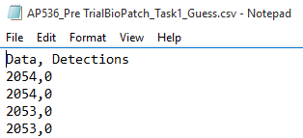

The pair of Squeeze Ball and BioPatch files have already been synchronized.

An absence of raw data files indicates an error. Either all five tasks are present or none are. Analysis cannot be performed without the raw data.

### Metrics

Header line contains subject and trial information. Two column CSV. First column is the metric, second column is the result.

### Graphs

Graphs will have be titled, each axis titled, color legend, detections clearly marked, and a line linking R-Peak and Squeeze detected pairs. These graphs are for lab members to review for any obvious defects.

# GUI Function

## GUI Strategy

In the absence of a 100% accurate R-Peak detection algorithm, we introduce a mix of automatic and manual R-Peak detection. The automatic detection attempts to find all R-Peaks but will invariably fail. Lab members are then asked to inspect the data and fix failures from the auto detection. Lab members would like to click and spend the least amount of time on R-Peak detection as possible.

Lab members aren’t trained in engineering or computer science but are familiar with basic computer operation. The GUI will lead lab members through a sequential set of operations:

1. Select from a list of available, valid trials
   1. Trials will be found in the /outputs/ folder
   2. Include provision to alert user if they are about to rerun analysis which will overwrite existing analysis
2. Load task ECG data and display a window that holds 5 seconds of ECG data
   1. User can click << or >> buttons to scroll through entire 60 seconds of data. I recommend scrolling 10 seconds at a time.
   2. Automatic R-Peak detections are included in ECG data as a red dot or other indicator
   3. User can click ‘remove R-peak’ or can click ‘add R-peak’ to interact with R-Peaks in data
   4. Data is saved by overwriting the .CSV file in /outputs/ with 1’s in the ‘Detections’ column
3. Repeat step 2 for all five tasks

After step 3, the user is done interacting with the GUI. The rest of the operations, listed in the Program Outline Section, are completed automatically.

GUI Special Notes:

* Trials will either have ALL five task data or NONE. If trials have NONE then it should not be available for analysis in the GUI.
* Expect for analysis to be redone. A ‘redo’ of the analysis should completely rewrite all analysis data, graphs. There are two conditions that could cause a ‘redo’.
  + **New Data Redo:** Raw data in the /outputs/ folder will be deleted and replaced with fresh data. This could happen if raw data was incorrectly named, or some other operation failed.
  + **R-Peak Detection Redo:** Lab member made mistakes during the R-Peak detection portion and need to redo. Original raw data has not changed.
* ECG Data will NEVER be inverted
* ECG Data will be 60 seconds of data sampled at 1000hz, so data files will have 60,000 samples +/- 25 samples.

## GUI Format

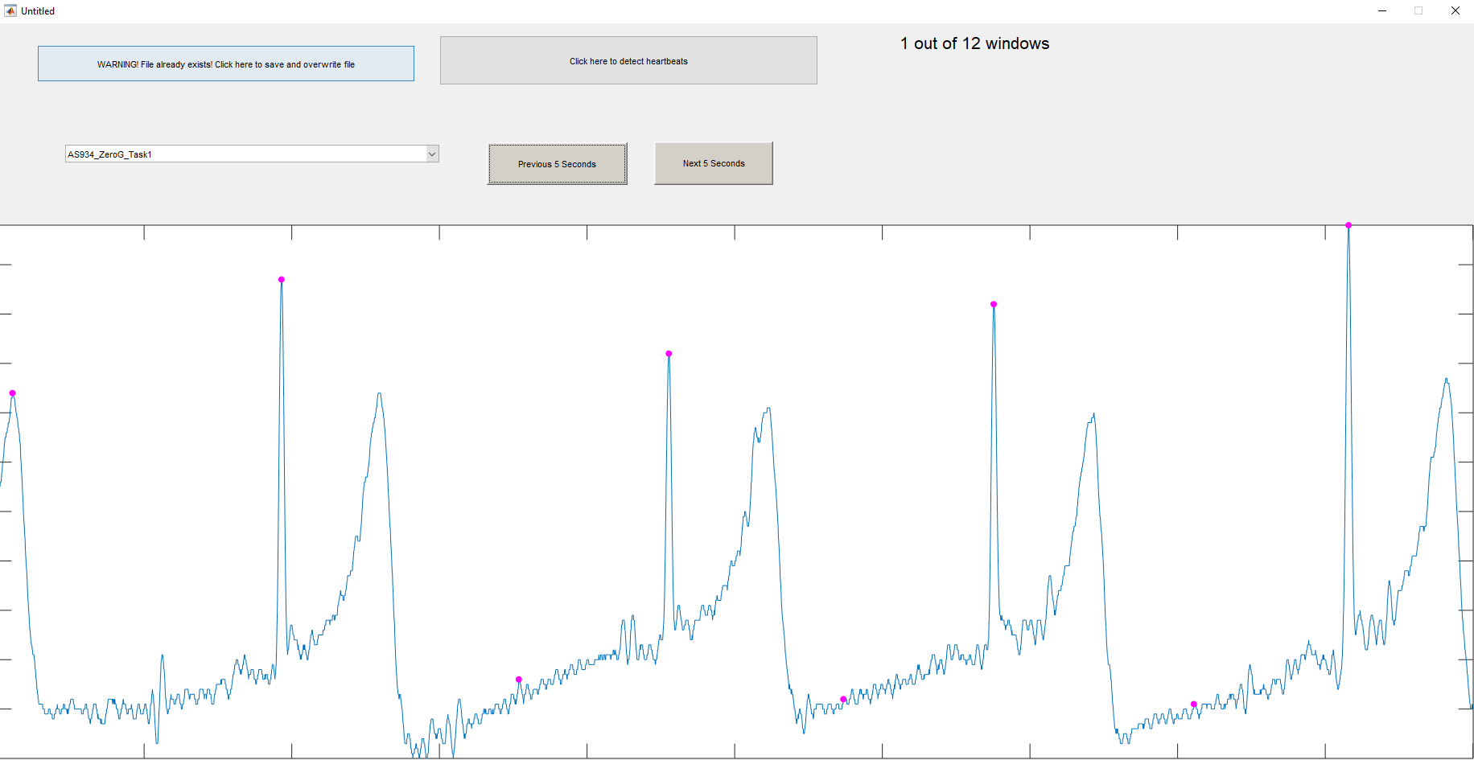Here’s an example of a GUI I created in MatLab that allows users to interact with ECG data. We see that a subject was selected through a drop down menu and that several buttons are available to scroll through ECG data, interact with data, and save. The purple dots are automatically generated R-Peak detections.

## (Not) Reinventing the GUI Wheel

In this section, I’ll go over all the design choices that I made and what inspired them. Usually, mistakes on my part caused suffering and I quickly revised the GUI to alleviate.

### ECG Data on Display

A window size of five seconds works well. It provides enough width to be able to view the waveforms and make accurate clicks. Windows crammed with ECG waveforms are hard to manage. Allow the windows to overlap a bit, most peak detection algorithms work best when you have a minimum number of data points to the left and right of the desired peak. Peaks very close to the window border would be difficult to detect, automatically or manually, otherwise.

Simple ‘previous window’ and ‘next window’ buttons are easy to implement and are clear in purpose. A text field keeping track of which window you are on is excellent for moral. “I only have five windows left to detect!”

**NOTE: Task2 has ‘tones’ as detections instead of R-Peaks. Task2 is not included in ECG detection.**

### ECG Automatic Detections

The purpose of the automatic detection is to take as much work as possible away from our lab members. Lab members would like to click and spend the least amount of time on R-Peak detection as possible.

Most generic R-Peak detection functions I’ve found online require some fine tuning or adjust to achieve their best performance. This is extremely difficult because our ECG data will vary between subject and will vary *within* subject.

Much time was spent trying to categorize ECG waves, using neural nets to classify waveforms, or use wavelet transformation theory to build a “catch-all” function. Regardless of the technique, the accuracy never reached over 95% for multiple subjects. Designing a generic function to detect all R-Peaks within any ECG dataset is fun but can’t be justified with the current time constraints. Here’s an example of the variation within ECG data. Below there are four QRS waveforms taken from different datasets and appended into the same axis.

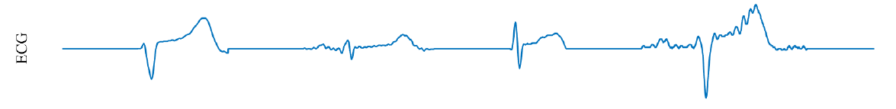

The most accurate and easiest to implement method is ‘Wavelet Transformation’ where a specific wavelet is convoluted with the ECG signal. The result is a signal with very distinct modules at the location of R-Peaks. Module locations are returned to the ECG signal to determine where valid R-Peaks are. The modules are more resistant to noise and other distortions than R-Peaks in filtered ECG data. The wavelet is chosen for the ECG R-Peak application. See refences [1], [2], [3], [4] for wavelet construction and application.

### R-Peak Detection Algorithm

The R-Peak Detection Algorithm is split into three separate components.

1. Create Finite Impulse Response Filter (FIR) with characteristics of the chosen wavelet.
   1. Convolute with ECG signal
2. Select valid modules from convoluted signal
   1. Valid module corresponds to valid R-Peak
3. Apply valid modules to ECG signal

The most common variations of ECG data are **R-Wave Prominence** and **T-Wave Prominence.** Review the QRS waveform in the ‘Project Overview’ section to distinguish R and T peaks. Based on the BioPatch application, the R or the T wave will be ‘prominent’ and dominate the waveform. See the above ECG examples. The first is T-Prominent and the third is R-prominent. An algorithm trained on T-Prominence will suffer when use don R-Prominence and vice versa. A compromise is to include both in the GUI and have the lab member select which auto-detection method to use.

### ECG Detection Interaction

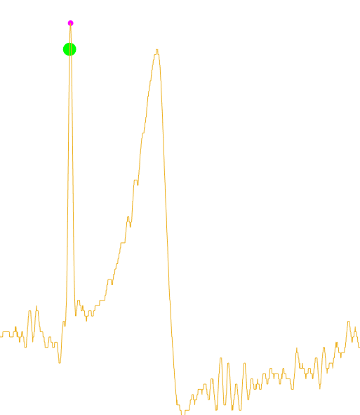There are two ways for the lab member to interact with the ECG data; remove a false detection or to add a positive detection. This can be combined in a single operation. The user will click and drag to specify regions in which there is a missing R-Peak or where there is a false-positive R-Peak. Each created region will only have one type of operation; remove or add. The graph will update to reflect the work of the user so they can check that their intended operation happened successfully.

### Save Function and Feedback

See ‘Program Data Organization’ for complete list of data files that will be modified and generated. For every ‘save’ operation, the user will be presented with a browser to select their intended save location.

The lab member will expect some sort of feedback directly from the GUI that will let them know if the save was successful. Some failures are mechanical (data wasn’t saved) and some failures are programmatic (lab member did something odd during R-Peak detection).

* All .CSV write operations were complete
  + Will fail if computer loses connection to network folder location
  + Will fail if user has .CSV file open in another program
* All new files were created (IFF not a ‘redo’) and write operations were complete
  + Will fail if computer loses connection to network folder location
  + Will fail if this is a ‘redo’ analysis and user has files open in another program
* All tasks and all windows were viewed
  + Will fail is lab member skipped tasks or windows, indicating they didn’t interact with the entire dataset
  + Task2 is not included in this check
* Gap equal to or more than 2000 ms between *any pair* of R-Peakdetections
  + Lab member missed an R-Peak as the average R to R interval is 1000ms
    - This varies greatly but 2000ms is a clear outlier that needs attention
  + If the subject had a natural 2000ms R to R interval they probably died or are at risk for a something going terribly wrong with their heart. See ‘Bradycardia’
* Gap less than or equal to 600 ms between *any pair* of R-Peak detections
  + A false positive R-Peak was not removed and creates an abnormally small R to R interval time. At 600 ms that would be 100 beats a minute
  + If the subject had a natural 100 beats a minute while resting, they are suffering from ‘tachycardia’

All of these can prevent a save function. Instead of crashing, or refusing to save, the GUI should alert the lab member to their failure and offer help to fix it. A pop-up message would be sufficient. Ex. “Please review window 5 of Task4 data. Possible R-Peak missing” or “Please close any open files”

A successful save should result in a positive message. The GUI should then be ready to run analysis on a completely new trial.

# Milestones

Milestones are listed here in chronological order and estimated number of hours.

|  |  |  |
| --- | --- | --- |
| Number | Description | Hours Expected |
| 0 | GUI Skeleton | +10 |
| 1 | Loading and Display ECG Data (No Detections) | +7.5 |
| 2 | Automatic Detection of ECG Data and Display | +7.5 |
| 3 | User Interact to Detect and Add R-Peaks | +7.5 |
| 4 | User Interact to Remove False R-Peaks | +7.5 |
| 5 | Automatic Detection of Squeezes | +10 |
| 6 | Save Squeeze and ECG Detections | +5 |
| 7 | Pair and Analyze Detections per Classic and T1000 Algorithm | +10 |
| 8 | Save Classic and T1000 Analyzed Data Results | +10 |
| 9 | Generate Image Collage | +10 |

Total: 90 Hours

# Code Review and Acceptance Test Procedure

A code review and Acceptance Test Procedure creates a paper trail of the success of the project and gives the customer confidence in their new product.

## Code Review

Code will be written with a consistent format and style following the PEP8 guidelines. A code review is expected within the week of handing in the completed project. The code review will entail an LIBR chosen Python expert who will review the code to make sure it follows industry standard.

## Acceptance Test Procedures (ATP)

Reference the individual ATP’s for their specific requirements. The ATP’s specify the success or failure of a certain feature of the project. All ATP’s together will cover the entire functionality of the Project. If any part of any ATP fails, then the project is considered incomplete. Completed ATP’s will remain with the customer.

# References

[1] Stephane Mallat, Sifen Zhong, “Characterization of Signals from Multiscale Edges,” *IEEE Transactions on Pattern Analysis and Machine Intelligence*, Vol 14. pp. 710-732, 1992.

[2] Cuiwei Li, Chongxun Zheng, Changfeng Tai, “Detection of ECG Characteristic Points Using Wavelet Transforms.” *IEEE Transactions on Biomedical Engineering,* Vol. 42. pp 21-28, 1995.

[3] Chio-In Ieong, Pui-In Mak,Chi-Pang Lam et al., “A 0.38-μW QRS Detection Processor Using Quadratic Spline Wavelet Transform for Wireless ECG Acquisition in 0.35-μm CMOS,” *IEEE Transactions on Biomedical Circuits and Systems,”* Vol 6. pp 586-595, 2012

[4] Hyung Wook Noh, Yongwon Jang, I.B. Lee et al. “A Preliminary Study of the Effect of Electrode Placement in Order to Define a Suitable Location for Two Electrodes to Obtain Sufficiently Reliable ECG Signals When Monitoring with Wireless System,” in *34th Annual International Conference of the IEEE EMBS*, San Diego, CA, 2012, pp 2124-2127

# Revision History

Each major revision will create a new, alphabetical REV Level. Changes are expected to be made for improving clarity. Any changes that result in adding or subtracting work hours will create a new, numerical REV Level. For example, if REV E adds a new feature to the project, it will be REV’d to 1/E.

|  |  |  |
| --- | --- | --- |
| Date | Rev Level | Revision |
| 8/1/2019 | - | Initial release. |
| 8/9/2019 | A | Incorporated redlines from meeting with Rayus. Added example files. |
| 9/13/2019 | B | Updated documents to reflect completion of QA GUI |
| 9/18/2019 | C | Added T1000 Algorithm and supporting documents |
| 10/14/2019 | D | Added GUI Layout section, added requirements, reorganized requirements. Added Milestones |
| 10/28/2019 | E | Changed section on R peak detections from a point-click method to a click-drag method. Changed file save/load sections from hard coded file locations to be user defined by way of browser. Added references to external document Project Statement of Work and ATP’s. Added the following sections: Code Review and Acceptance Test Procedure (ATP). |
| 11/7/2019 | F | Added Resampled Precision specifics. Added descriptions to metrics of Classic and T-1000 algorithms. Added file contents. |
| 11/30/2019 | G | Added wavelet R-Peak detection information and references. |
| 12/4/2019 | H | Added file contents and image specifications. |
|  |  |  |
|  |  |  |
|  |  |  |
|  |  |  |